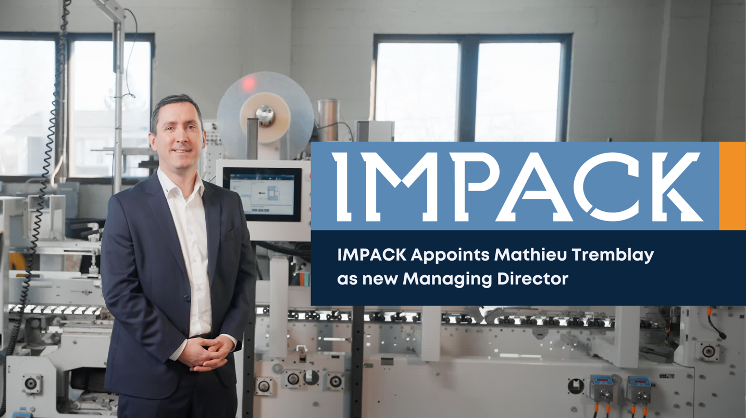

FOR IMMEDIATE RELEASE
IMPACK Appoints Mathieu Tremblay as Managing Director
January 8, 2025 | Saint Jacques, Quebec, Canada
IMPACK is proud to announce the appointment of Mathieu Tremblay as Managing Director. A dedicated team member since 2003, Mathieu’s leadership journey and expertise have been pivotal in shaping IMPACK’s reputation as a leader in specialized automation for the packaging industry.
A Proven Leader
Mathieu’s career with IMPACK began as an intern in 2003. After completing his engineering degree, he rejoined in 2005, steadily advancing through key roles, including Engineering Project Coordinator (2013), Director of Engineering (2016), Director of Production and Engineering (2020) and Deputy General Manager (2021). His appointment as Managing Director is a testament to his commitment and vision for the company.
Reflecting on this milestone, Mathieu expressed gratitude and optimism:
"I’m grateful for the opportunity to lead IMPACK into a promising future. I am committed to building on our strong foundation by expanding our automation portfolio and fostering collaborations that drive innovation in packaging solutions."
Driving Innovation and Collaboration
Under Mathieu’s leadership, IMPACK will continue to tackle industry bottlenecks, leveraging engineering expertise to enhance efficiency and productivity for folding carton and corrugated box producers. The company’s commitment to innovation and strategic partnerships remains at the forefront of its 2025 objectives.
Founder Dominic Theriault spoke to Mathieu’s qualities:
"Mathieu’s expertise and dedication inspire trust—both within our team and among our clients. His leadership reflects the values of cooperation and equity that define IMPACK."
Dominic originally championed IMPACK’s unique cooperative structure where ownership of the company is shared with the employees. He will now transition into a strategic role as president of IMPACK, focusing on business stability and development.
About IMPACK
IMPACK specializes in designing and manufacturing automation solutions for the folding carton and corrugated box industries. For over 20 years, the company has addressed workflow bottlenecks with innovative products, including pre-feeders, packers, and counting modules.
Rooted in values of cooperation, collaboration, and partnership, IMPACK helps packaging producers optimize operations and meet industry challenges such as labor shortages and rising costs.
For media inquiries, please contact:
Fawn Alleyne
Marketing Manager, IMPACK
1 450 839 7272 | fawna@impack.ca | www.impack.ca

-----

BOX:
Cooperation
Collaboration
Partnership

--------

Image: Mathieu Tremblay

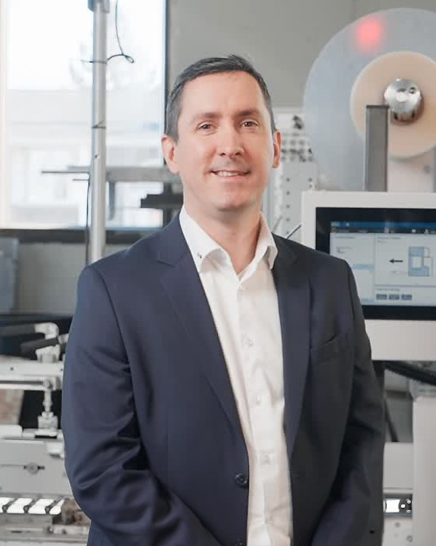
Image: Dominic Theriault
