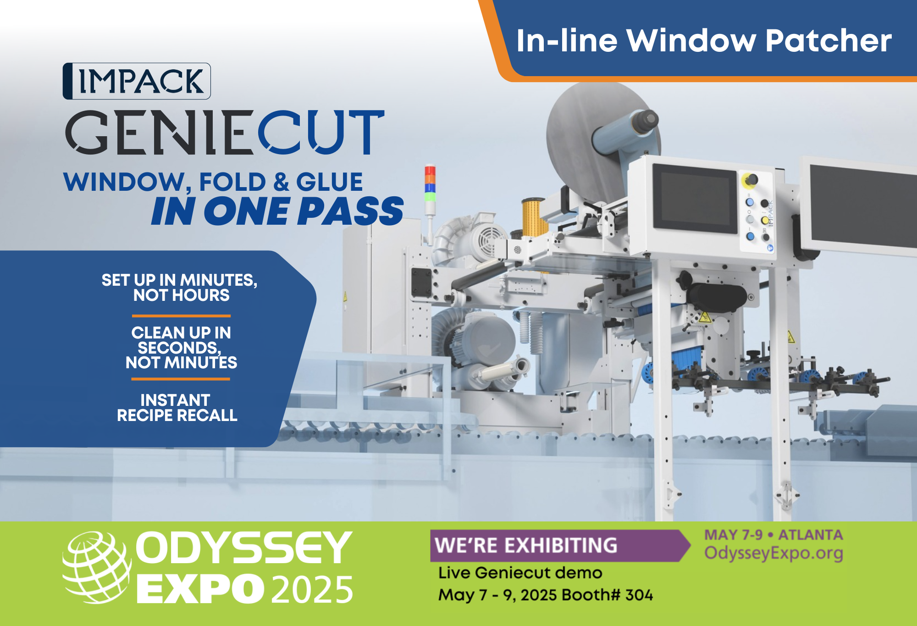

**FOR IMMEDIATE RELEASE**  
**IMPACK to Showcase GenieCut Live for the First Time at Odyssey Expo 2025**

April 17, 2025 | Saint Jacques, Quebec, Canada

IMPACK is excited to announce its participation at Odyssey Expo 2025, taking place May 7–9 in Atlanta, Georgia. This year marks a milestone for IMPACK, as we present the GENIECUT live for the very first time in the U.S. — a revolutionary system redefining window application in the packaging industry.

The GENIECUT allows packaging producers to add windows to packaging right on your folder-gluer. This eliminates the need for additional operators, space and logistics. Join us for live demonstrations in the TECHSHOP and see firsthand how GENIECUT can transform your workflow. You’ll see how the GENIECUT’s cutting-edge design reduces changeover time and increases efficiency.

Visitors will also have the opportunity to meet IMPACK’s Director of Sales, Bertrand Beaulieu, who will be available throughout the event for personalized consultations. This is your chance to discuss your automation goals, challenges, and potential ROI directly with a key decision-maker.

Supporting our growing presence in the U.S., Sales Agent Doug Herr will also be on site to connect with attendees and address the unique demands of the American market. Doug’s expertise and local insight make him an essential part of IMPACK’s commitment to helping U.S. clients automate with confidence.

“Expos like Odyssey give us the opportunity to showcase how IMPACK’s automation technology and collaborative approach can support manufacturers in meeting their evolving production and safety needs,” said Bertrand Beaulieu, Director of Sales at IMPACK. “It’s about working together to find the right solutions for more efficient and secure operations.”

### **Don’t Miss Out!**

**Booth #: 304**  
**Location:** Cobb Galleria Centre, Atlanta, GA USA  
**Dates:** May 7–9, 2025

For more information, or to schedule a one-on-one meeting at the show, visit <https://impack.ca/odyssey-expo-2025> or contact us directly.

**About IMPACK**

IMPACK is an engineering company that designs and manufactures automated folder-gluer peripherals for folding carton and corrugated box packaging producers. Our comprehensive product range includes in-line window patchers, pre-feeders, box turners, packers, stackers, batch inverters, as well as counting and separating modules. Our collaborative approach ensures that our clients get tailored solutions that eliminate bottlenecks and optimize workflows.

With over 20 years of experience analyzing packaging production workflows and methods, our machines are meticulously engineered based on insights gained from thousands of client interactions. We design solutions that help operators and packers to work more ergonomically and efficiently so that they can increase folder-gluer speed and ultimately production capacity.

For media inquiries, please contact:  
**Ruth Castro**

Marketing & Communications Specialist

IMPACK

+1 450-499-6087

[rcastro@impack.ca](mailto:rcastro@impack.ca)

[www.impack.ca](http://www.impack.ca/)

-----

BOX:

Cooperation

Collaboration

Partnership

--------

Image: Bertrand Beaulieu Boulanger



Image: Geniecut

