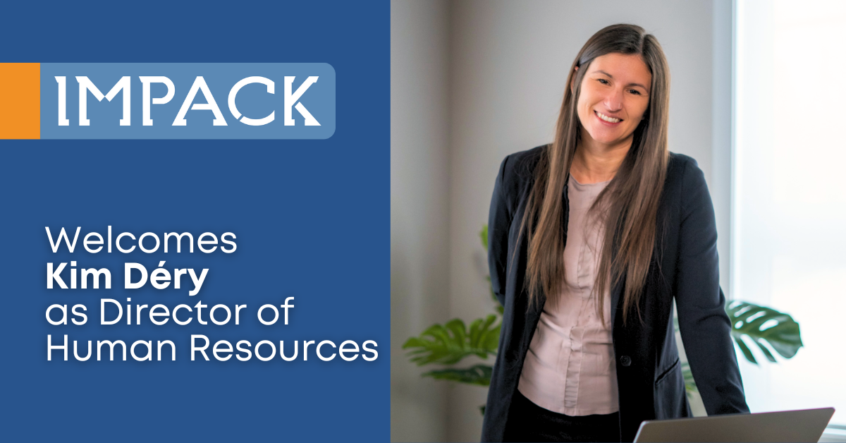

### **FOR IMMEDIATE RELEASE** **IMPACK Welcomes Kim Déry as Director of Human Resources**

*February 25, 2025 | Saint Jacques, Quebec, Canada*

IMPACK is pleased to announce the appointment of Kim Déry as its new Director of Human Resources. With over eight years of experience in HR management and consulting, Kim specializes in staff retention, talent development and crisis management. She brings a deep understanding of workplace culture, leadership development, and employee engagement, making her a key addition to the IMPACK team.

Kim joins IMPACK as a shared part-time resource through Alliance Métal Québec, allowing her to leverage her expertise across multiple organizations while driving impactful HR strategies at IMPACK.

### **A People-First Approach to HR**

Throughout her career, Kim has led recruitment, employee engagement, and performance management initiatives across industries such as engineering, programming, and plant operations. She has worked closely with leadership teams to develop HR policies that attract and retain top talent while ensuring a positive and high-performing workplace.

A graduate of the Université de Montréal with a bachelor’s degree in psychology and a diploma in administration, Kim has further honed her expertise through training at HEC Montréal and AtmanCo, deepening her strategic approach to HR leadership. Beyond her HR leadership roles, she has worked as an HR consultant, coaching entrepreneurs to build positive, high-performing workplaces that foster collaboration and innovation.

### **Strengthening IMPACK’s Team**

Before joining IMPACK, Kim played a key role in HR strategy and organizational development at Alliance Métal Québec, La Boîte RH, and SOGICA INC. She has helped small and medium-sized businesses develop HR frameworks that prioritize people while driving long-term success. Her expertise in organizational development, HR strategies, and fostering innovation aligns with IMPACK’s commitment to building a strong and engaged workforce.

“I’m excited to join IMPACK and contribute to a team that values innovation and collaboration. My passion has always been creating workplaces where people feel empowered, engaged, and supported in their growth. I look forward to working alongside IMPACK’s leadership to build strategies that strengthen our culture and help our teams thrive,” said Kim Dery.

“We’re excited to welcome Kim Déry to the IMPACK team,” said **Mathieu Tremblay, Managing Director**. “Her expertise in building strong, inclusive teams and her people-first leadership style will be a tremendous asset as we continue to grow.”

As IMPACK expands globally, Kim will lead HR initiatives that enhance workplace culture, employee engagement, and leadership development.

**About IMPACK**

IMPACK specializes in designing and manufacturing automation solutions for the folding carton and corrugated box industries. For over 20 years, the company has addressed workflow bottlenecks with innovative products, including pre-feeders, packers, and counting modules.

Rooted in values of cooperation, collaboration, and partnership, IMPACK helps packaging producers optimize operations and meet industry challenges such as labor shortages and rising costs.

For media inquiries, please contact:  
**Ruth Castro**

Marketing & Communications Specialist

IMPACK

+ 1-873-973-3000

[rcastro@impack.ca](mailto:rcastro@impack.ca)

[www.impack.ca](http://www.impack.ca/)

---------

Image: Kim Déry



Image: Mathieu Tremblay

