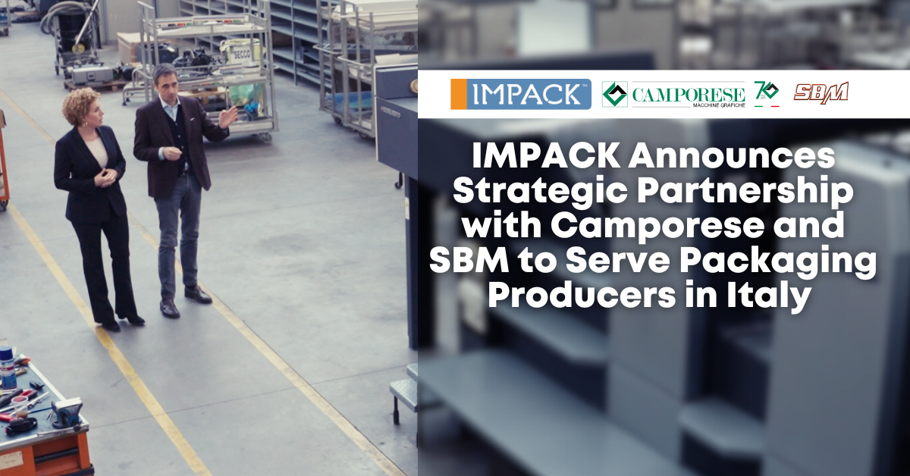

### **FOR IMMEDIATE RELEASE** **IMPACK Announces Strategic Partnership with Camporese and SBM to Serve Packaging Producers in Italy**

*March 20, 2025 | Saint Jacques, Quebec, Canada*

IMPACK is happy to announce a strategic collaboration with Camporese Macchine Grafiche S.P.A. and SBM S.R.L., delivering a seamless, one-stop shopping experience to packaging producers across Italy. This partnership brings together three industry leaders, each known for their expertise, to offer tailored, high-performance packaging solutions that drive efficiency, maximize productivity, and ensure long-term value.

“This partnership is about more than just equipment—it’s about providing a complete solution,” said **Mathieu Tremblay, Managing Director of IMPACK**. “By working together with **Camporese and SBM**, we’re making it easier for Italian packaging producers to integrate automation, optimize their folder-gluer lines, and get the expert support they need to keep production running smoothly.”

Camporese has been a trusted name in the Italian printing and packaging industry for over 70 years. Known for their deep industry expertise, they specialize in sourcing and supplying high-quality, “like new” refurbished printing and packaging equipment. Through this partnership, Italian producers can now seamlessly pair their folder-gluers with IMPACK’s automated packers, ensuring their finishing line is optimized for efficiency.

“We chose our partners very carefully,” explained Bruno Camporese, CEO of Camporese Macchine Grafiche S.P.A. “When you enter Camporese you immediately realize that the focus is on the customer, and in SBM you find the same mentality. They take the same meticulous care when making technical interventions and providing technical assistance. Our customers expressed the need to increase the speed of the end-of-line operations of the folder-gluer. IMPACK is a manufacturer of excellence, having many years of experience in the sector.”

SBM technicians will provide expert local support, including start-up assistance, training, and ongoing service. This ensures packaging producers can implement automation quickly and effectively, maximizing the productivity of their folder-gluer lines without disruption.

As part of the partnership, clients will be able to schedule live demos and tests at the SBM showroom near Milan. Marie-Soleil Boutet, Area Sales Manager at IMPACK, highlighted why the Italian market is the perfect setting for this demonstration:

*“The Italian packaging market is incredibly diverse, from major global players to numerous small-to-medium size producers handling a variety of box types in smaller runs. The ERGOSA Packer is the perfect fit for this reality—its minimal setup time and ability to process all kinds of boxes give these businesses the versatility they need to stay competitive and efficient.”*

**Get Hands-On with Automation at Print4All**

IMPACK, Camporese, and SBM are bringing a fully interactive, hands-on experience to Print4All in Milan from May 27 to 30, 2025. Visitors will have the exclusive opportunity to operate it themselves—packing boxes and experiencing its efficiency firsthand.

This live, interactive demonstration is designed to show industry professionals exactly how the ERGOSA packer optimizes production, reduces manual labor, and enhances workflow automation. Instead of just watching, attendees can step into the operator’s role and get a feel for how simple, fast, and ergonomic the system is.

### **Event Information**

**Event**: Print4All – Packaging and Printing Technology Exhibition  
**Dates**: May 27–30, 2025  
**Location**: Milan, Italy – Hall 9, Stand R27/S26

To learn more about the ERGOSA packer and the IMPACK-Camporese collaboration, visit impack.ca

**About IMPACK**

IMPACK is an engineering company that designs and manufactures automated folder-gluer peripherals for folding carton and corrugated box packaging producers. Our comprehensive product range includes in-line window patchers, pre-feeders, box turners, packers, stackers, batch inverters, as well as counting and separating modules. Our collaborative approach ensures that our clients get tailored solutions that eliminate bottlenecks and optimize workflows.

With over 20 years of experience analyzing packaging production workflows and methods, our machines are meticulously engineered based on insights gained from thousands of client interactions. We design solutions that help operators and packers to work more ergonomically and efficiently so that they can increase folder-gluer speed and ultimately production capacity.

**About Camporese**

Camporese is a global leader in sourcing, supplying, and refurbishing used graphic equipment, including folder-gluers, sheet-fed offset printing presses, and die-cutting machines. With decades of expertise, they provide a full range of professional services, from machine upgrades and retrofits to complete remanufacturing. Their meticulous refurbishment process includes thorough inspection, cleaning, repair or replacement of defective components, painting, calibration, and test-printing to ensure optimal performance. Renowned in the packaging industry for their commitment to innovation and precision, Camporese continues to deliver advanced solutions that enhance production efficiency and extend the lifecycle of essential equipment.

**About SBM**

Founded in 2006 by Sergio Bocchio, S.B.M. draws on extensive expertise to provide technical assistance for die-cutters used in paper, solid board, and corrugated board production, as well as BM and BMA hot-stamping machines and Bobst-brand folder-gluers. In recent years, the company has bolstered its workforce to offer rapid on-site technical support, complemented by a 24/7 telephone hotline that ensures continuous availability. Among its core services, S.B.M. operates a dedicated training center for die-cutting and hot-stamping professionals, delivering both classroom-based instruction and on-site production courses tailored to beginners and seasoned operators alike.

For media inquiries, please contact:  
**Ruth Castro**

Marketing & Communications Specialist

IMPACK

+ 1-873-973-3000

[rcastro@impack.ca](mailto:rcastro@impack.ca)

[www.impack.ca](http://www.impack.ca/)

---------

Image: Bruno Camporese

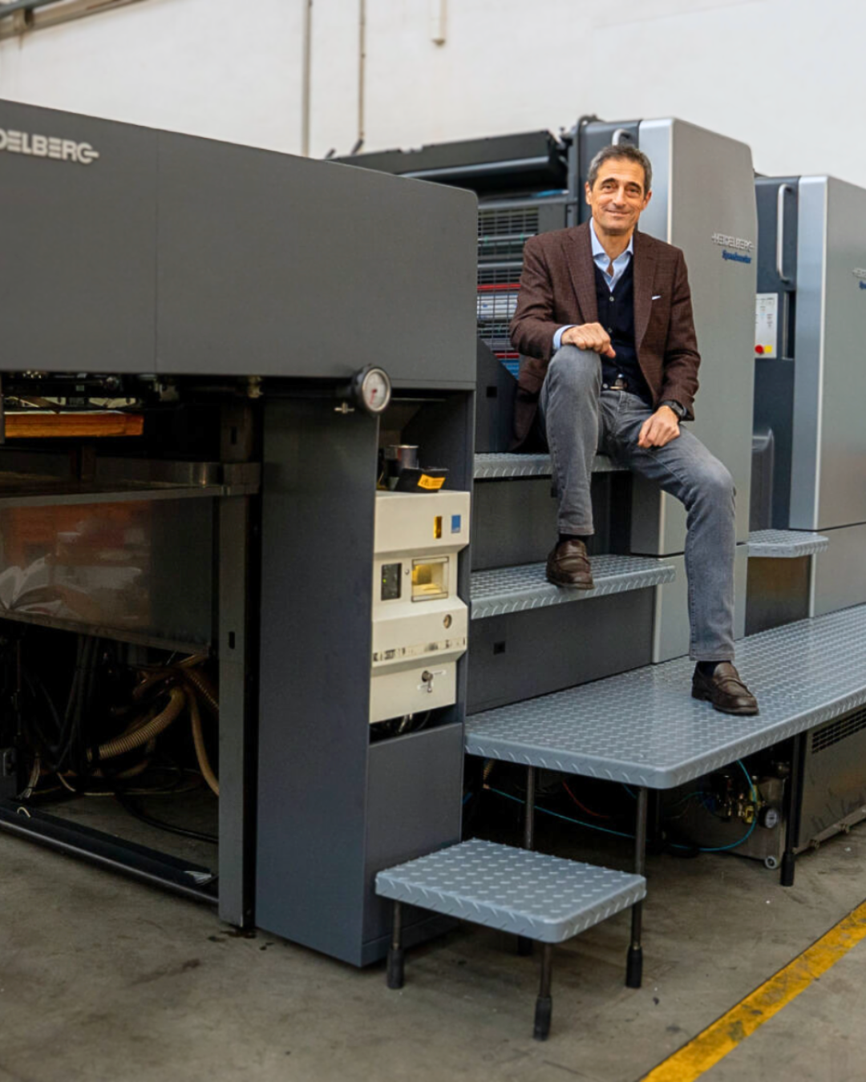

Image: Mathieu Tremblay

