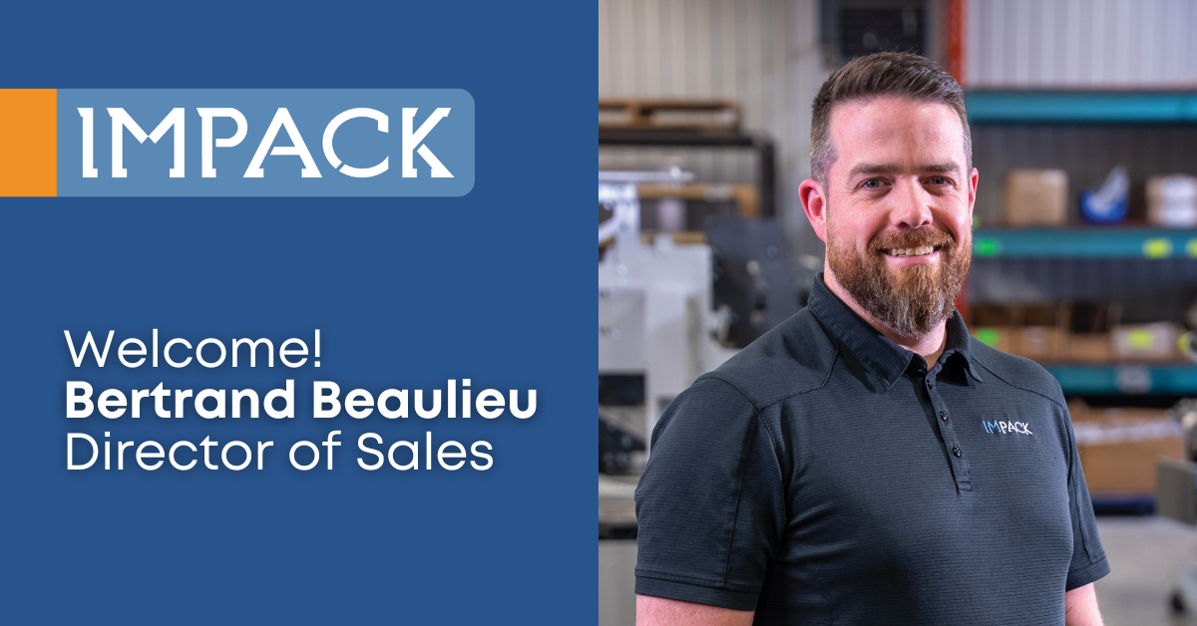

**FOR IMMEDIATE RELEASE**  
**IMPACK Welcomes Bertrand Beaulieu as New Director of Sales**

March 26, 2025 | Saint Jacques, Quebec, Canada

IMPACK is pleased to announce the appointment of Bertrand Beaulieu as its new Director of Sales. Bertrand brings a wealth of expertise in team leadership, process optimization, and customer relations to his new role. He has over 12 years of experience in sales, operations and service management during his time at KASCO LLC, where the needs of customers and employees were his top priority.

In his new position at IMPACK, Bertrand will oversee the company’s sales strategy, strengthen client relationships, and drive business development initiatives. Bertrand’s focus on matching products to customer needs aligns perfectly with IMPACK’s mission to provide cutting-edge automated solutions tailored to industry needs.

“We are pleased to welcome Bertrand to the IMPACK team,” said Mathieu Tremblay, Managing Director of IMPACK. “His extensive experience in operations and sales leadership, coupled with his strategic mindset and dedication to customer satisfaction, make him the perfect fit to lead our sales team into the future. We look forward to the contributions he will make in expanding our market reach and enhancing our client partnerships.”

Bertrand Beaulieu said, “I’m excited to step into this new industry and contribute to a company that puts customer needs first. Their commitment to quality is evident—they take pride in building machines that solve client problems and focus on delivering exceptional service to every client. From day one, it was evident that IMPACK’s leadership values every team member’s contribution and fosters a supportive work environment. I look forward to contributing to IMPACK’s culture and mission.”

**About IMPACK**

IMPACK is an engineering company that designs and manufactures automated folder-gluer peripherals for folding carton and corrugated box packaging producers. Our comprehensive product range includes in-line window patchers, pre-feeders, box turners, packers, stackers, batch inverters, as well as counting and separating modules. Our collaborative approach ensures that our clients get tailored solutions that eliminate bottlenecks and optimize workflows.

With over 20 years of experience analyzing packaging production workflows and methods, our machines are meticulously engineered based on insights gained from thousands of client interactions. We design solutions that help operators and packers to work more ergonomically and efficiently so that they can increase folder-gluer speed and ultimately production capacity.

For media inquiries, please contact:  
**Ruth Castro**

Marketing & Communications Specialist

IMPACK

+1 450-499-6087

[rcastro@impack.ca](mailto:rcastro@impack.ca)

[www.impack.ca](http://www.impack.ca/)

-----

BOX:

Cooperation

Collaboration

Partnership

--------

Image: Bertrand Beaulieu Boulanger

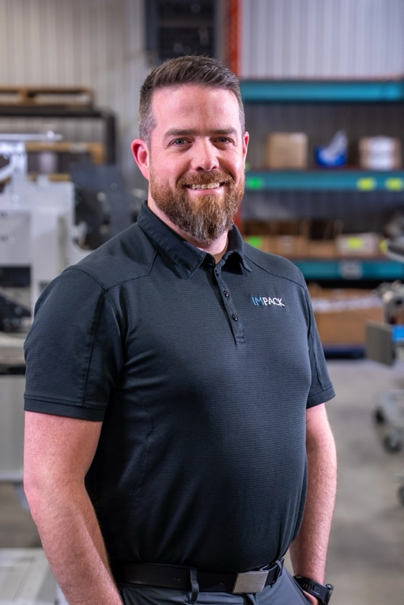

Image: Mathieu Tremblay

