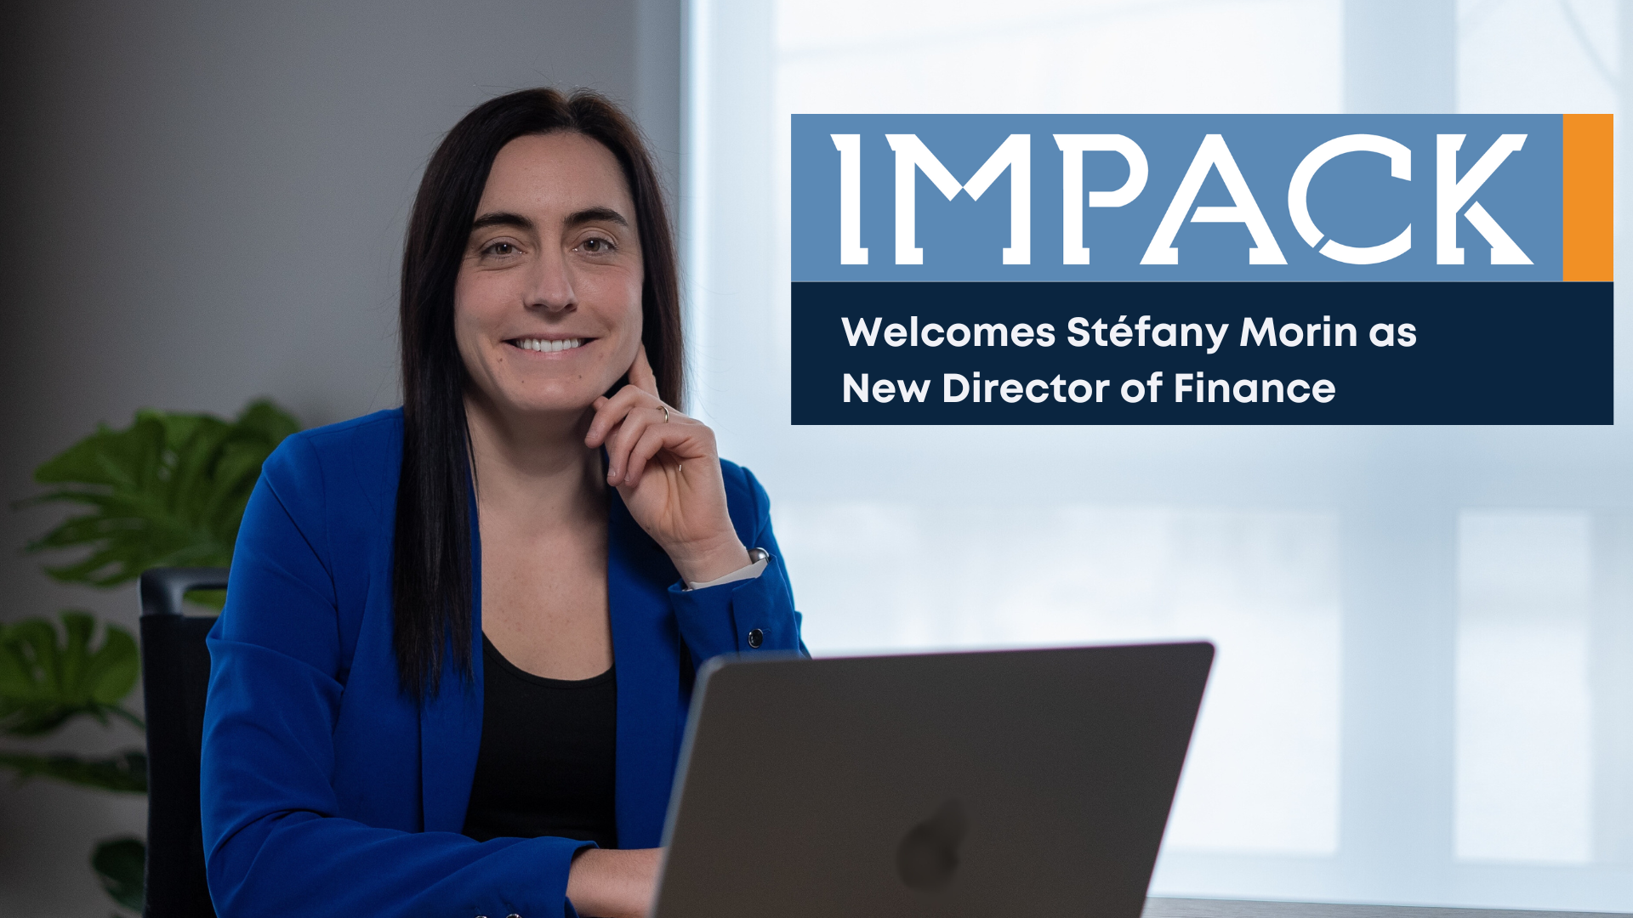

**FOR IMMEDIATE RELEASE**  
**IMPACK Welcomes Stéfany Morin as New Director of Finance**

*January 30, 2025 | Saint Jacques, Quebec, Canada*

IMPACK is pleased to announce the appointment of Stéfany Morin as Director of Finance, expanding its leadership team as it continues to grow as an international leader in automation for the packaging industry.

Stefany brings over a decade of experience in financial management, accounting, and strategic planning. Prior to joining IMPACK, she spent more than five years at Raymond Chabot Grant Thornton as a **Senior Auditor**, specializing in financial analysis and reporting for small and medium-sized enterprises (PME). Her ability to navigate complex financial structures and her hands-on approach to fiscal strategy have made her a trusted expert.

Before that, she held key financial roles at Clermont et Clermont S.E.N.C.R.L, where she focused on financial data analysis and planning.

“As IMPACK continues to expand, we are strengthening our leadership team with experienced professionals who align with our vision and share our values,” said **Mathieu Tremblay, Managing Director at IMPACK** “Stéfany’s depth of financial expertise and strategic mindset will be invaluable as we scale operations and drive long-term growth.”

In her new role, S Stéfany will oversee IMPACK’s financial strategy, ensuring the company remains agile and well-positioned for its next phase of expansion. Her appointment reflects IMPACK’s commitment to building a strong and diverse leadership team.

“I am excited to join IMPACK at such a pivotal moment and to contribute to its continued success,” said **Stéfany Morin**. “I look forward to working alongside a talented team and supporting the company’s financial and strategic goals.”

Stéfany joins a growing team of directors at IMPACK, reinforcing the company’s commitment to strong leadership and operational excellence.

**About IMPACK**

IMPACK specializes in designing and manufacturing automation solutions for the folding carton and corrugated box industries. For over 20 years, the company has addressed workflow bottlenecks with innovative products, including pre-feeders, packers, and counting modules.

Rooted in values of cooperation, collaboration, and partnership, IMPACK helps packaging producers optimize operations and meet industry challenges such as labor shortages and rising costs.

For media inquiries, please contact:  
**Ruth Castro**

Marketing & Communications Specialist

IMPACK

+1 450-499-6087

[rcastro@impack.ca](mailto:rcastro@impack.ca)

[www.impack.ca](http://www.impack.ca/)

-----

BOX:

Cooperation

Collaboration

Partnership

--------

Image: Stéfany Morin



Image: Mathieu Tremblay

