
FOR IMMEDIATE RELEASE
IMPACK Welcomes Doug Herr as New Sales Agent for the United States
February 4, 2025 | Saint-Jacques, Quebec — IMPACK is delighted to welcome Douglas Herr as a Sales Agent in the United States. With 48 years of experience in the converting and packaging industries, Doug brings a wealth of knowledge in capital equipment, investments, and strategic planning—making him a perfect fit for IMPACK’s customer-first approach.
Mathieu Tremblay, Managing Director of IMPACK, expressed his enthusiasm for this new collaboration: “Doug’s unparalleled expertise and dedication to helping businesses thrive align perfectly with IMPACK’s mission of providing cutting-edge packaging solutions. We are confident that his presence will strengthen our relationships with U.S. clients and drive our growth in this important market.”
Doug Herr shared his excitement about joining IMPACK: “I’m honored to partner with IMPACK, a company renowned for its reliability and innovative approach to packaging equipment. I look forward to leveraging my experience to support clients across the United States, ensuring they have the insights and tools needed to make informed decisions and achieve lasting success.”
Doug Herr will continue IMPACK’s long track record of collaborating with clients to provide expertise and tailored solutions to our shared clients. His focus on strategic growth and building strong client-vendor partnerships will be instrumental in driving IMPACK’s success in the region.
For more information about IMPACK and its innovative packaging solutions, visit www.impack.ca.
About IMPACK
IMPACK is an engineering company that designs and manufactures folder-gluer peripherals for folding carton and corrugated box packaging producers. Our comprehensive product range includes in-line window patchers, pre-feeders, box turners, packers, stackers, batch inverters, as well as counting and separating modules. Our collaborative approach ensures that our clients get tailored solutions that eliminate bottlenecks and optimize workflows.
With over 20 years of experience analyzing packaging production workflows and methods, our machines are meticulously engineered based on insights gained from thousands of client interactions. We design solutions that help operators and packers to work more ergonomically and efficiently so that they can increase folder-gluer speed and ultimately production capacity.
Media Contact:

Ruth Castro
Marketing & Communications Specialist
IMPACK
+1 450-499-6087
rcastro@impack.ca
www.impack.ca


Doug Herr, Herr Packaging Solutions, LLC, U.S.A.
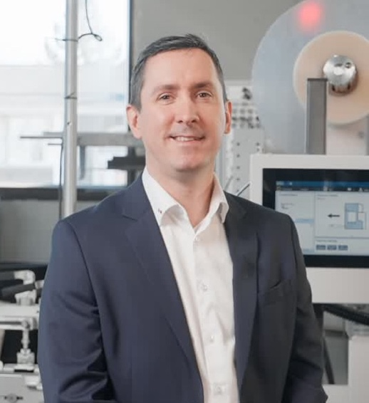
Mathieu Tremblay, Managing Director, IMPACK
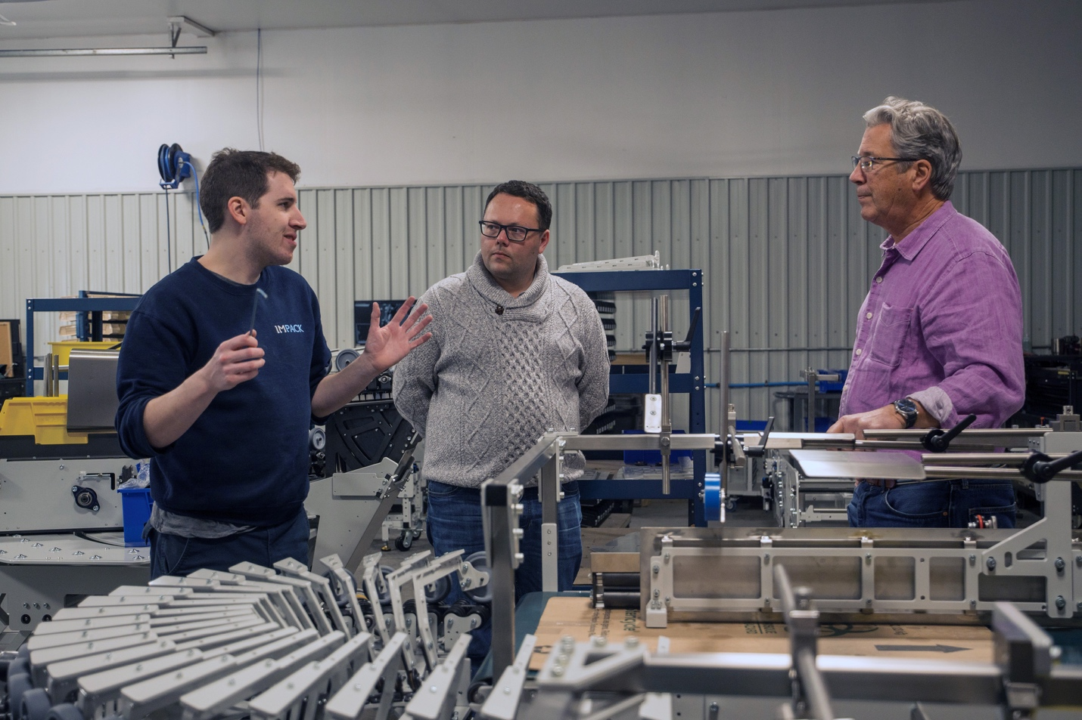
Doug Herr(right) meets with IMPACK’s Director of Engineering, David Leblanc(left) and IMPACK’s Sales Team Leader, Maxime Jacques(center)

